NEWSLETTER

No. 06, Term 01, Week 11

Monday 09 April 2018

Greetings, Kia ora, Talofa lava, Kia orana, Malo e lelei, Fakalofa Lahi Atu, Namaste, An Young Haseyo, Konichiwha, Bula Vinaka, Sawadee, Dobra Dan, Ni Hao, As-salamu alaykum, Hola

From the Principal – Mrs. Watt

Message from the Principal
It is with great sadness that we farewell Mrs Evans, Room 1 classroom teacher, at the end of this term in her permanent, part time capacity at our school. Elma has worked for over 20 years as a teacher at our school and has decided to semi-retire. We will still continue to see her around our school in a reliving capacity. We will be hosting a special assembly on the last day of term at 2pm if you would like to join with us and celebrate her contributions to our school.

Welcome
A big huge welcome to our new families who have started in our Junior School. We look forward to working alongside you and welcome you to our PDS whanau.

PDS Open Day
Thank you to our whanau who attended this last Friday. We hope you enjoyed watching your child’s learning in the classroom and interacting with them. The children enjoyed seeing you. We hope to see more whanau at future open days.

Panmure District School Baking Programme
Just a reminder to parents and whanau that the baking programme is still on this week and it will continue in the second term. Hope to see as many parents participating in this interesting workshop designed by our school social worker.

Duffy Assembly
Thank you to our guest speaker Marc Duffy. He was very inspirational when delivering his message of always using can instead of cannot. We are also grateful to our Duffy sponsor –
The Rotary Club of Ellerslie.

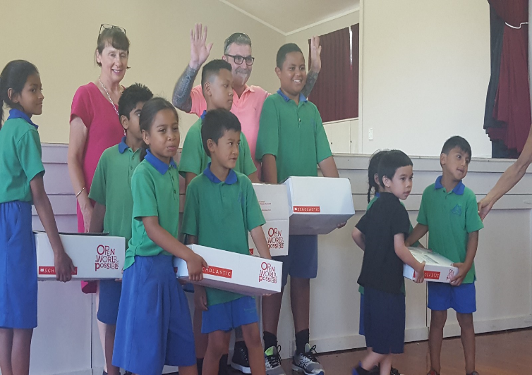

ASB Banking
We can now offer school banking. Banking day is on Friday. Forms are located on the Kashin the Elephant bank deposit box in our reception area. When children sign up to open an ASB account, they will be sent a Kashin deposit box and calculator in a yellow bag - all to keep. If you’d like to register your child for free, for this, please see our friendly office staff.

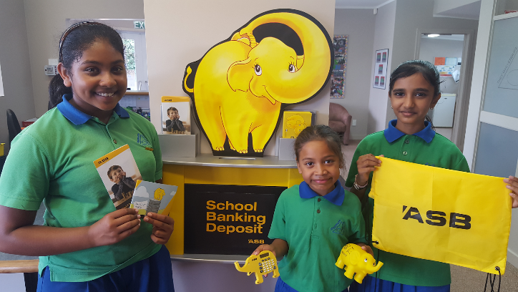

A great way to teach our students how to handle and understand the value of money in everyday life.

Winning House
Congratulations to our house winner - PURIRI.
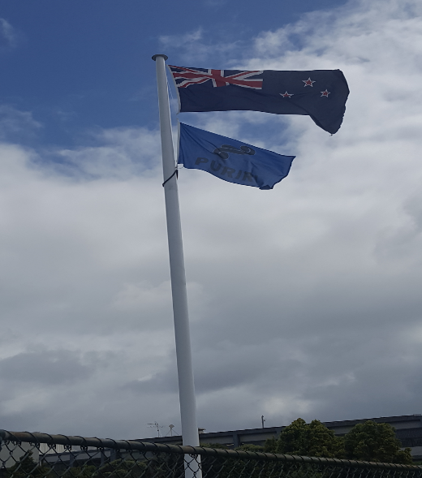

Free Lunchtime skating session
This will be for Rooms 3, 5 and 7 only as there is an age limit. Children will be provided with skates and wrist bands. If you would like your child to wear a helmet, please send this with them on their skate day. Please see below:
Room 5: Tuesday
Room 7: Wednesday
Room 3: Thursday

Skateland Holiday Skate Programme:
Skate School programme will begin in Term 2, Tuesday 1st May 4-5pm @ Skateland,
66 Mountain Rd, Mt Wellington. A learn to skate programme for beginners (Private, one on one coaching). The first lesson is FREE.
To book, email: rollersports@skateland.co.nz

Children will receive a free VIP PASS, this entitles the bearer to a FREE learn to skate class on Saturday mornings 10-11am @ Skateland. No bookings required, unlimited spaces for skaters.

Term 2 Uniforms
A reminder that winter uniform is to be worn next term. There are both second hand ($5-$15) and new jumpers ($42) available at the school office.

Term 2 dates
Monday 30th April - 1st day of Term 2
Thursday 10th May - whole-school Temple visit

The last day of school is this Friday 13th April. School will close at the usual time of
Merit Awards
Room 1 -
Taison Ngfor taking his classroom duties responsibly.
Gamza Dakum for achieving good progress in reading.

Room 2 –
Alliyah Abadiano for speaking confidently in front of an audience.
Franz Rama for his effort in taking on the role of the story teller.

Room 3 –
Kierstin Idago for making steady progress and improvement with all areas of her learning.
Josiah Vea for showing consistent effort with his learning and using RISE and Values

Room 05 –
Krishna Patel for her extensive research skills on Winter and Paralympics Inquiry Topic.
Fakatua Kaufusi for improving her work habits in the class.

Room 07 –
Dontrae Te Maro for showing intelligence to extend learning in own time.
Samiya Baker for demonstrating the ability to use the multiplication facts when solving multiplication word problems.

Environmental Award:
Room 3 – for making an effort to RISE for property by keeping their front classroom area litter free.

